**NAME : K.KARTHIK**

**REGISTER NUMBER:192110178**

**SUBJECT : CSA1006 SOFTWARE ENGINEERING WITH UML**

**1)** Draw a use case diagram to model for Online Voting System. A web-based voting system that will help to manage elections easily and securely, the voter should be able to successfully cast his vote or it should be a failure. There should be no intermediate state. In case of failures the voter should be allowed to retry immediately. The voting data should be consistent throughout the system. If we are replicating the data, we do not want any scenario where one database shows Voter-1 has voted Candidate-1 and another database has an old entry for Voter-1 showing he has voted for Candidate-2. We should always have strong consistency.

**AIM:**

To Draw a use case diagram for online voting system using Case tools

**SOFTWARE USED:**

Umbrello

**DIAGRAM:**

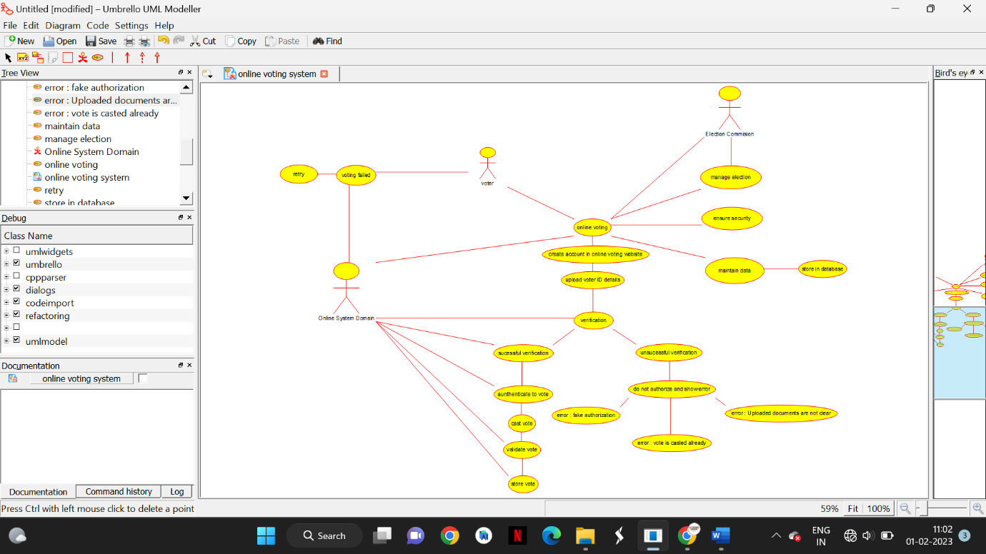

K.KARTHIK

192110178

**RESULT :**

Drawing a use case diagram for the online voting system is completed successfully

**(2)** Draw a use case diagram for Library Management System is an automation system used to manage a library and the different resource management required in it like cataloguing of books, allowing check out and return of books, invoicing, user management, etc. The user can search for book details using a few book properties (Book ID, Title, Author, and Publisher). Searching should return details about all the book copies that match the search query.

**AIM:**

To Draw a use case diagram for Library Management system using Case tools

**SOFTWARE USED:**

Umbrello

**DIAGRAM:**

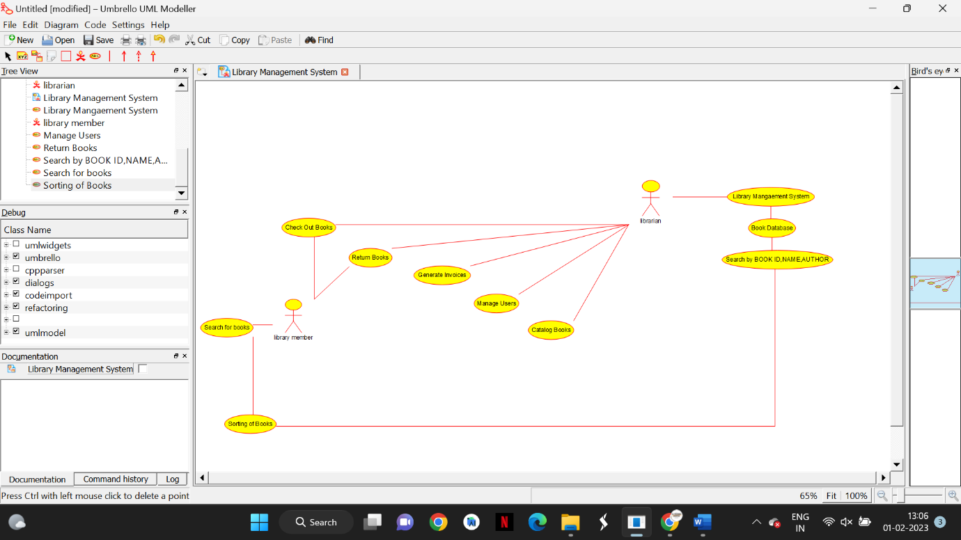

K.KARTHIK

192110178

**RESULT :**

Drawing a use case diagram for the library management system is completed successfully

**3)** Draw and validate Flowchart to compute quotient and remainder between two integers can be calculated by using the division ( / ) and modulus ( % ) operators respectively. To compute the remainder of the division of two floating point numbers, the library function fmod() is used. This function considers quotient as an integer number and the remainder as a floating point number.

**AIM:  
T**o Draw and validate flowchart to compute quotient and remainder

**SOFTWARE USED:**

Raptor

**DIAGRAM:**

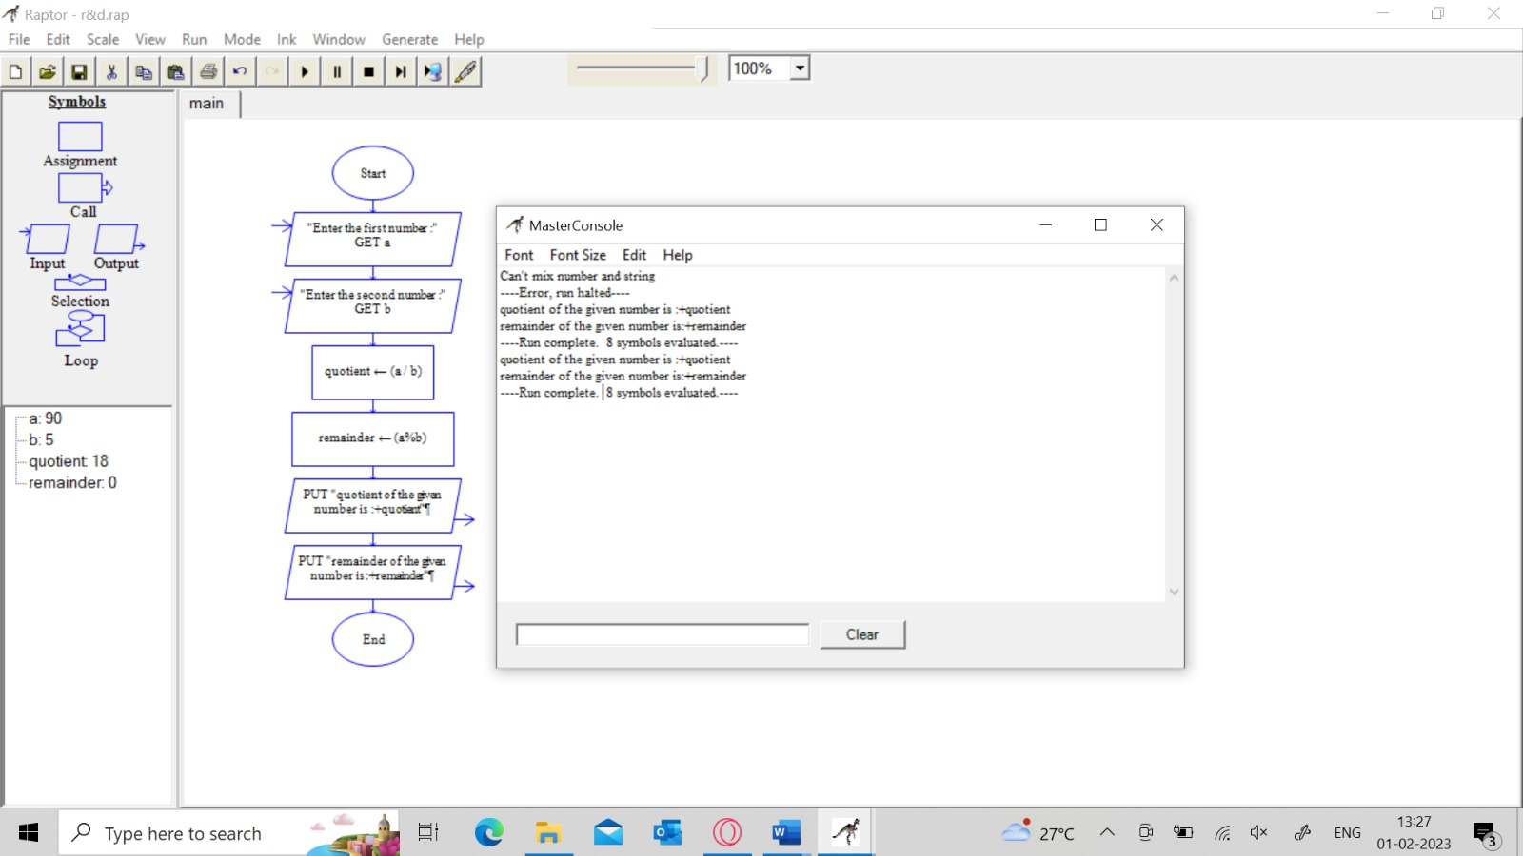

K.KARTHIK

192110178

**RESULT :**

Drawing and validating a flowchart to compute quotient and remainder is completed successfully

**4)** Design a shopping cart system. How is the cart updated when the application is open on multiple pages? When an item is added to the cart, store the update in the server. Therefore a page refresh on any tab will keep everything up to date. If you don't want to rely on a refresh, you could try some sort of polling mechanism. If the web browser on Focus event happens (assuming it's there), poll the server for a quick update if there is one

**AIM:**

To Draw a use case diagram for Shopping cart system using Case tools

**SOFTWARE USED:**

Umbrello

**DIAGRAM:**

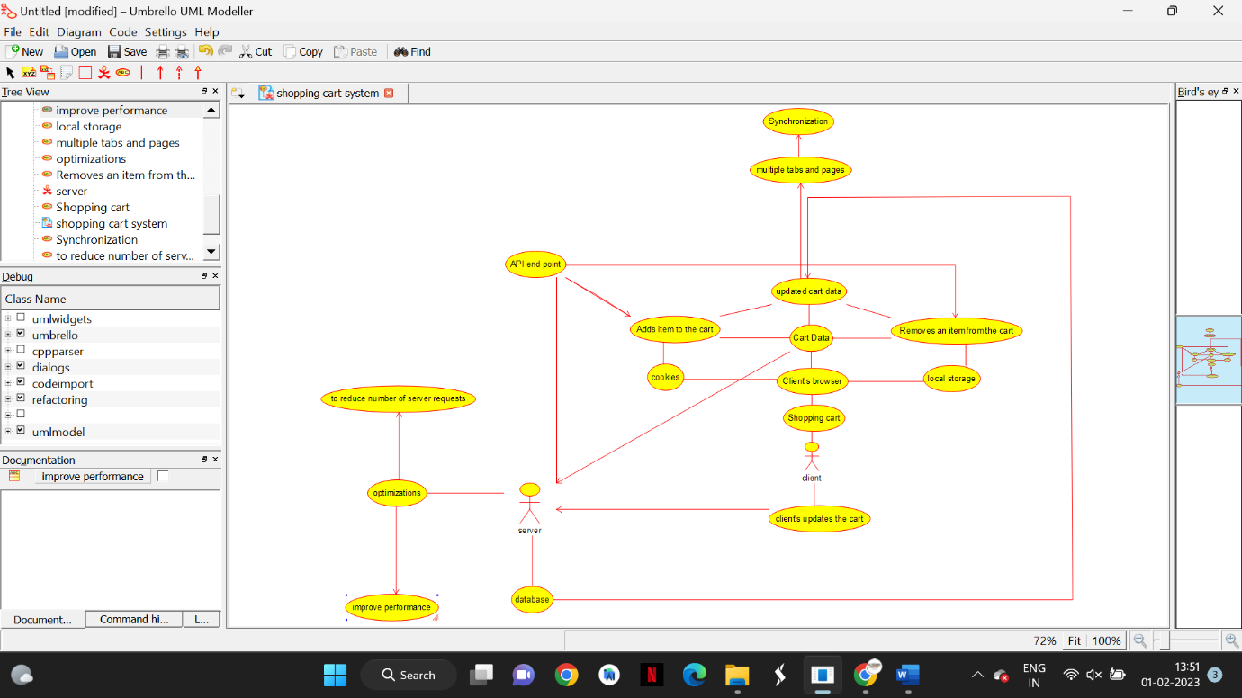

K.KARTHIK

192110178

**RESULT :**

Drawing a use case diagram for the library management system is completed successfully

**5)** Draw the use case diagram is a graphic depiction of the interactions among the elements of the Railway reservation system for maintaining admin user can search ticket, view the description of a selected ticket, add a ticket, update a ticket and delete a ticket and its shows the activity flow of editing, adding and updating of the customer. The user will be able to search and generate reports of payment, Booking and train schedules.

**AIM:**

To Draw a use case diagram for Shopping cart system using Case tools

**SOFTWARE USED:**

Umbrello

**DIAGRAM:**

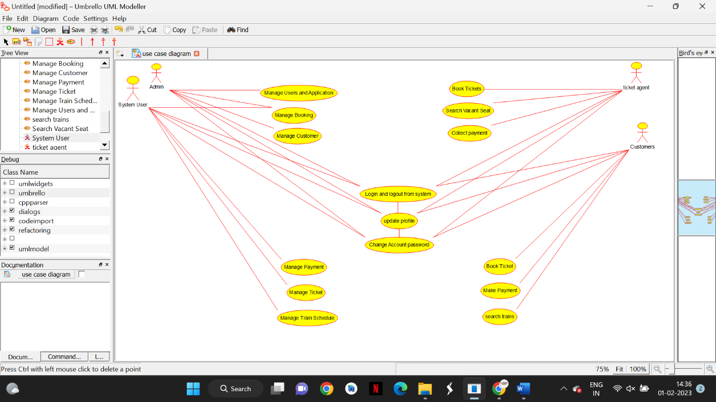

K.KARTHIK

192110178

**RESULT :**

Drawing a use case diagram for the railway ticket system is completed successfully

**6)** Draw a USE-CASE diagram for the Hospital Management System. The activities of the hospital system are listed below. Receive the patient id, Patient name, pharmacy,laboratory,doctor,administrator,record officer, test report, drug management, test management, user management, dispense drug using CASE tools.

**AIM:**

To Draw a use case diagram for Hospital Management using Case tools

**SOFTWARE USED:**

Umbrello

**DIAGRAM:**

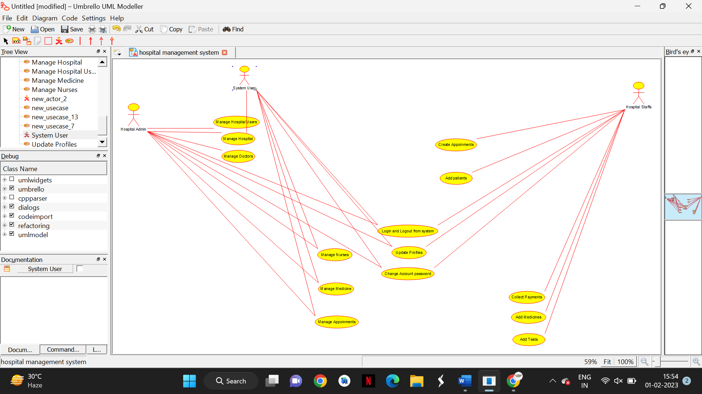

K.KARTHIK

192110178

**RESULT :**

Drawing a use case diagram for the hospital management system is completed successfully

**7)** Draw a USE-CASE diagram for an ATM System using CASE tool. The banking system allows a customer to access the financial transactions by ATM System, it has a step by step process describing the work of this process and elaborate what work can be done by customer, banking system, administrator and technicians with the ATM system.

**AIM:**

To Draw a use case diagram for ATM system using Case tools

**SOFTWARE USED:**

Umbrello

**DIAGRAM:**

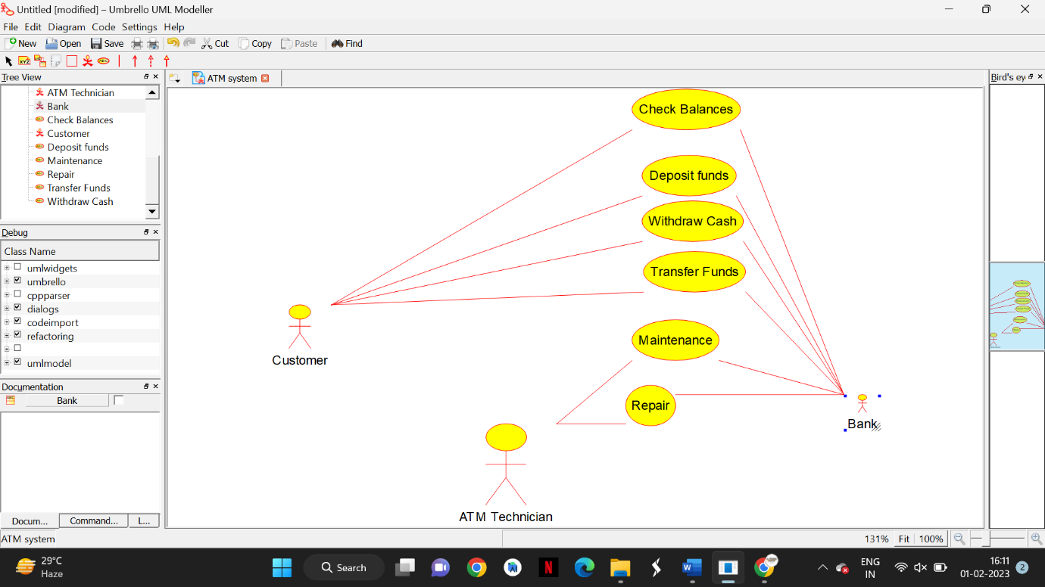

K.KARTHIK

192110178

**RESULT :**

Drawing a use case diagram for the ATM system is completed successfully

**8)** Draw a USE-CASE diagram for Online college management System Manage students information and status, Manage courses and subjects, Manage Instructors and designation, Record all transactions

**AIM:**

To Draw a use case diagram for Online College Management System using Case tools

**SOFTWARE USED:**

Umbrello

**DIAGRAM:**

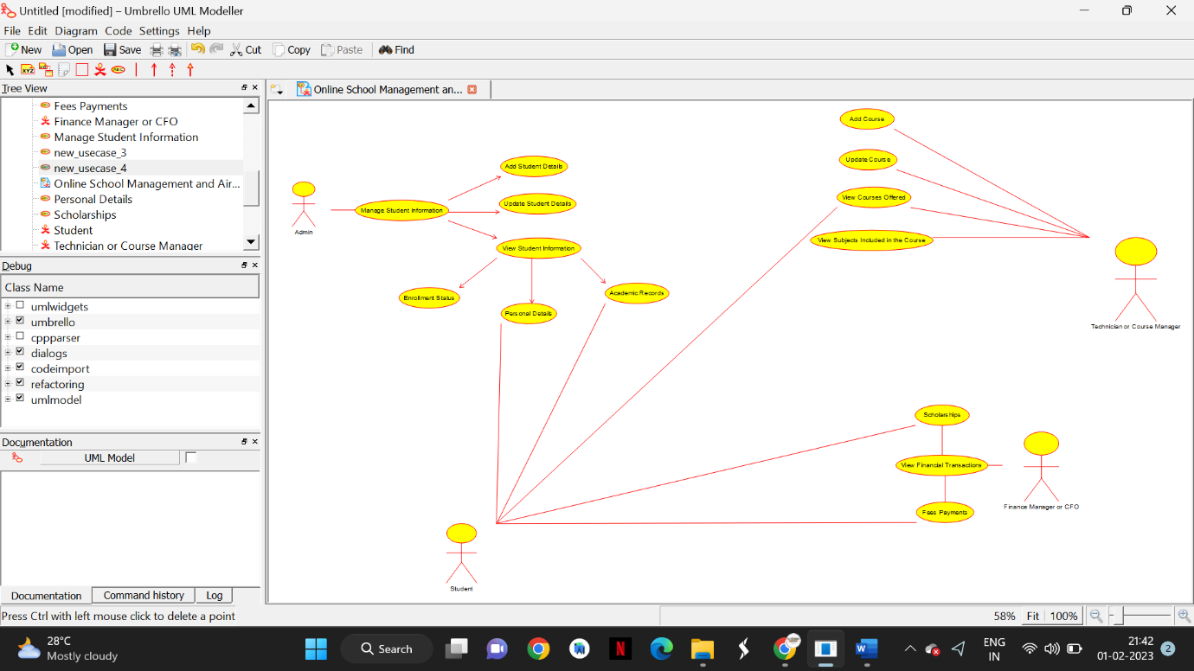

K.KARTHIK

192110178

**RESULT :**

Drawing a use case diagram for the Online College Management System

**9)** Draw a USE-CASE diagram for Online Airline Management System which is a dedicated and highly configurable system for all airlines, which can be easily accessed by all users. It helps the users to book flights without visiting offline booking counters. This system can be accessible by any user from any location at any time. In such a system, a passenger should be able to view the availability of flights’ details, as per their requirement. They can book the flights online and can also cancel the reservation. The administrator manages the passenger booking system and updates the reservation status using CASE tools.

**AIM:**

To Draw a use case diagram for Online College Management System using Case tools

**SOFTWARE USED:**

Umbrello

**DIAGRAM:**

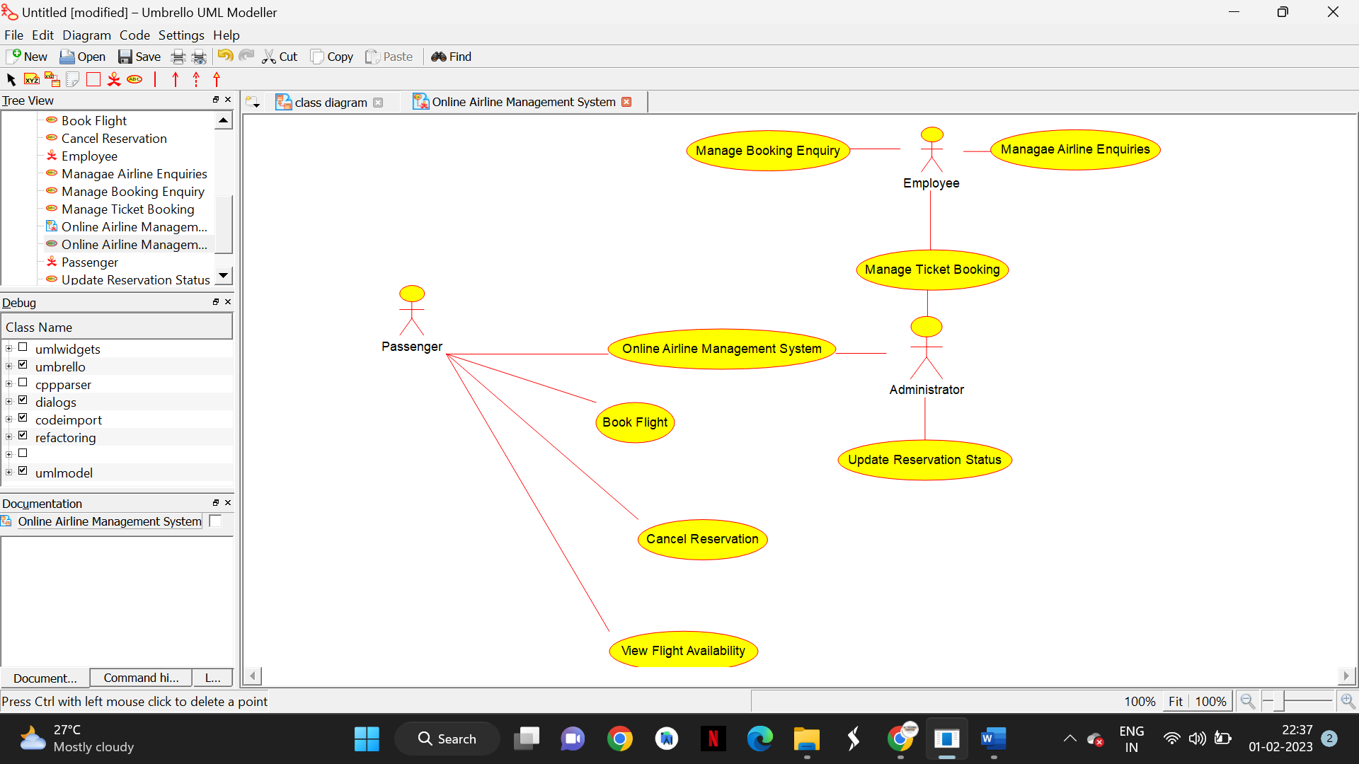

K.KARTHIK

192110178

**RESULT :**

Drawing a use case diagram for the Online College Management System is completed successfully

**10)** Make an Online Airline Reservation System. The activities of the Online Airline Reservation system are listed below user, admin, LOGIN, MANAGE CLASSES, MANAGE WAITING LIST, MANAGE HOLDS, MANAGE DEADLINES, LOGOUT, using this has a step-by-step process

**AIM:**

To Draw a use case diagram for Online Airline Reservation System using Case tools

**SOFTWARE USED:**

Umbrello

**DIAGRAM:**

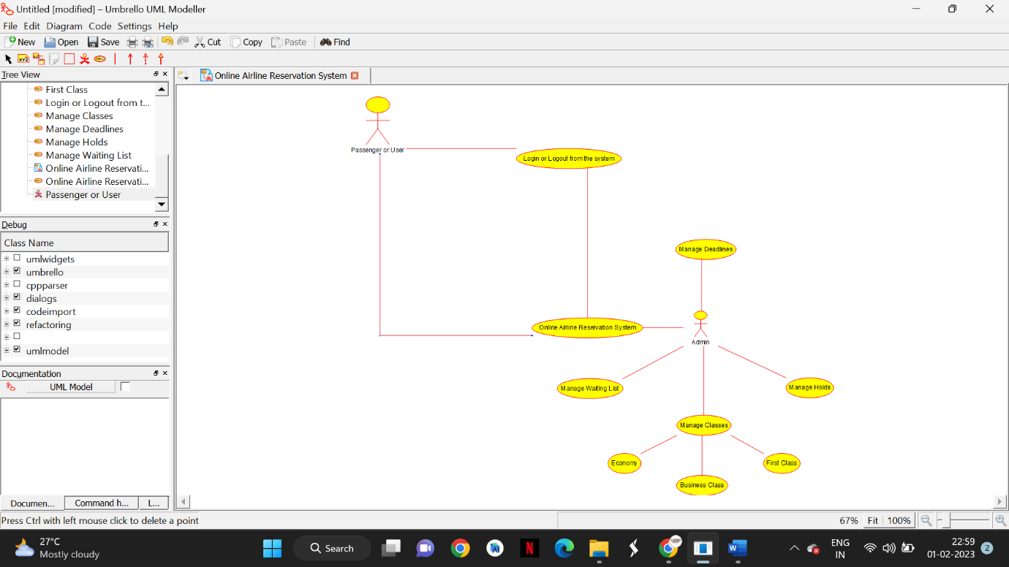

K.KARTHIK

192110178

**RESULT :**

Drawing a use case diagram for the Online Airline Reservation System is completed successfully

**11)** Draw a Class diagram for Online Voting System using CASE tools. E-Vote is an election system that facilitates voters to record their secure and secret ballot electronically. It has a friendly user interface and enables voters to cast their votes in a few simple steps. We ensure the authenticity of the voters and the votes cast by them along with non-traceability of the casted vote elaborate the whole process of e-voting.

**AIM:**

To Draw a class diagram for Online e-Vote System using Case tools

**SOFTWARE USED:**

Umbrello

**DIAGRAM:**

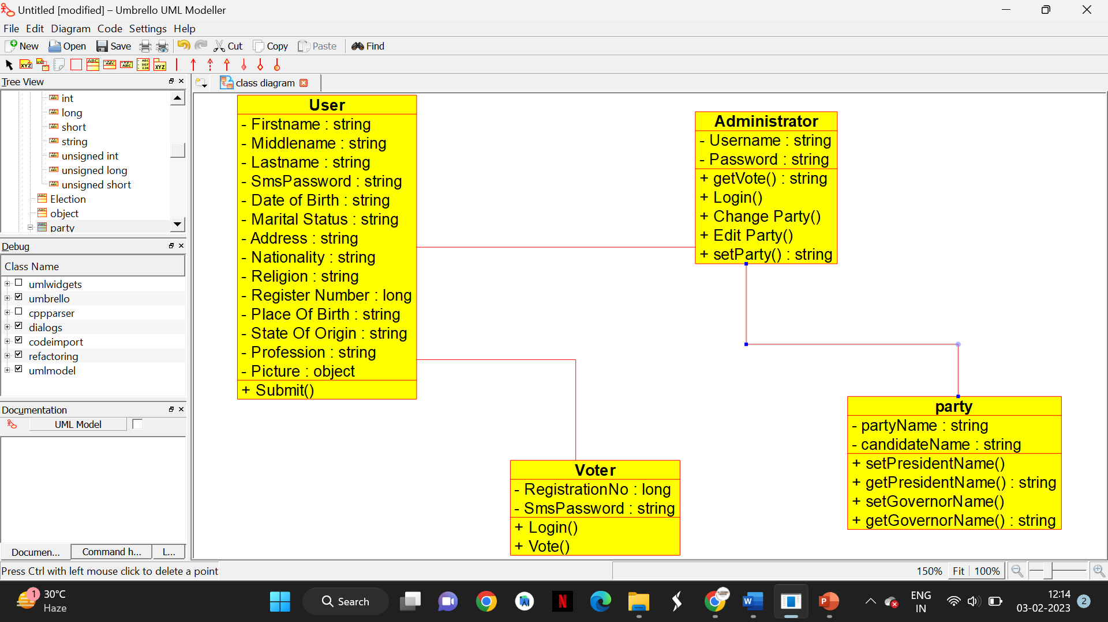

K.KARTHIK

192110178

**RESULT :**

Drawing a class diagram for the Online e-Vote System is completed successfully

**12)** Draw a Class diagram for Library Management System using CASE tools.designing use case diagram for the library management system. User who registers himself as a new user initially is regarded as staff or student for the library system. Librarians have a key role in this system. Librarian adds the records in the library database about each student or user every time issuing the book or returning the book, or paying a fine. Design the class diagram for this

**AIM:**

To Draw a class diagram for Library Management using Case tools

**SOFTWARE USED:**

Umbrello

**DIAGRAM:**

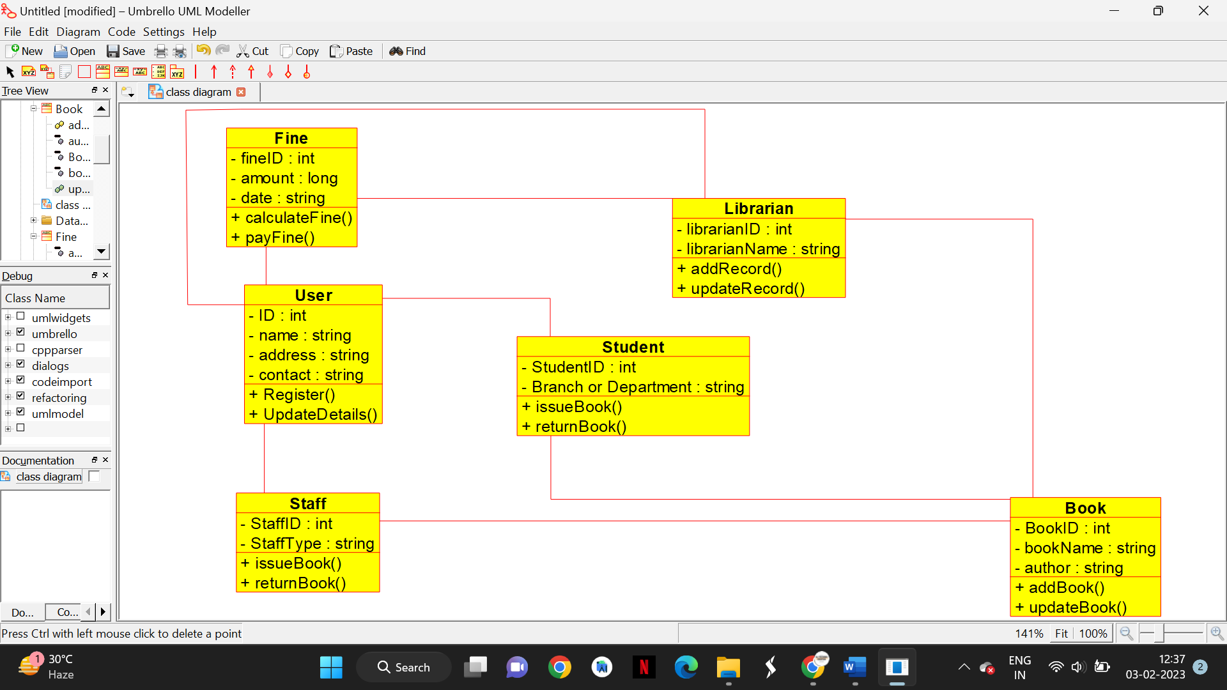

K.KARTHIK

192110178

**RESULT :**

Drawing a class diagram for the Library Management System is completed successfully

**13)** Draw a Activity diagram for Online Voting System for a software platform that allows groups to securely conduct votes and elections using CASE tools. The voters should be able to register via some proper authority. Construct a system in which the voters should see the list of candidates present in his constituency. A voter should be able to cast his vote to a candidate and that voter should cast only 1 vote at a time

**AIM:**

To Draw a activity diagram for Online Voting using Case tools

**SOFTWARE USED:**

Umbrello

**DIAGRAM:**

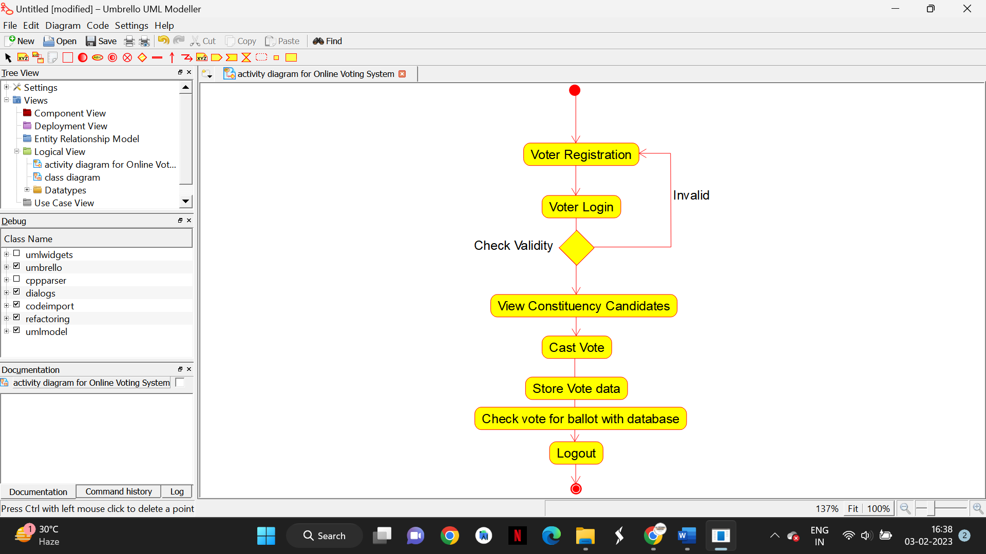

K.KARTHIK

192110178

**RESULT :**

Drawing a activity diagram for the Online Voting System is completed successfully

**14)** Draw a Activity diagram for Library Management System using CASE tools constructing User who registers himself as a new user initially who is regarded as staff or student. After getting the library card, a new book is requested by the user. After, requesting, the desired book issue the book to the user. Renew the book if the user needs the book again. Add the agent as Librarian and the user in the activity diagram

**AIM:**

To Draw a activity diagram for Library Management System using Case tools

**SOFTWARE USED:**

Umbrello

**DIAGRAM:**

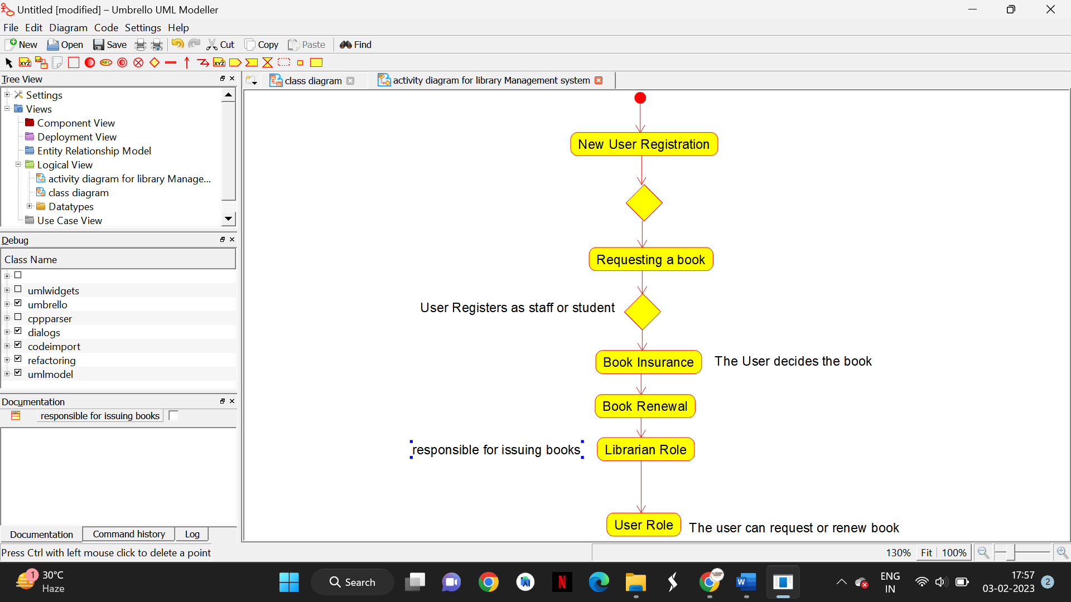

K.KARTHIK

192110178

**RESULT :**

Drawing a activity diagram for the Library Management System is completed successfully

**15)** Draw an Activity diagram for the Online Shopping system using CASE tools with standard steps like Login, Search, Browse, Add to cart, edit cart, delete cart, Confirm purchase, make payments, receive items, rate website login and logout on the system.

**AIM:**

To Draw a activity diagram for Online Shopping cart system Case tools

**SOFTWARE USED:**

Umbrello

**DIAGRAM:**

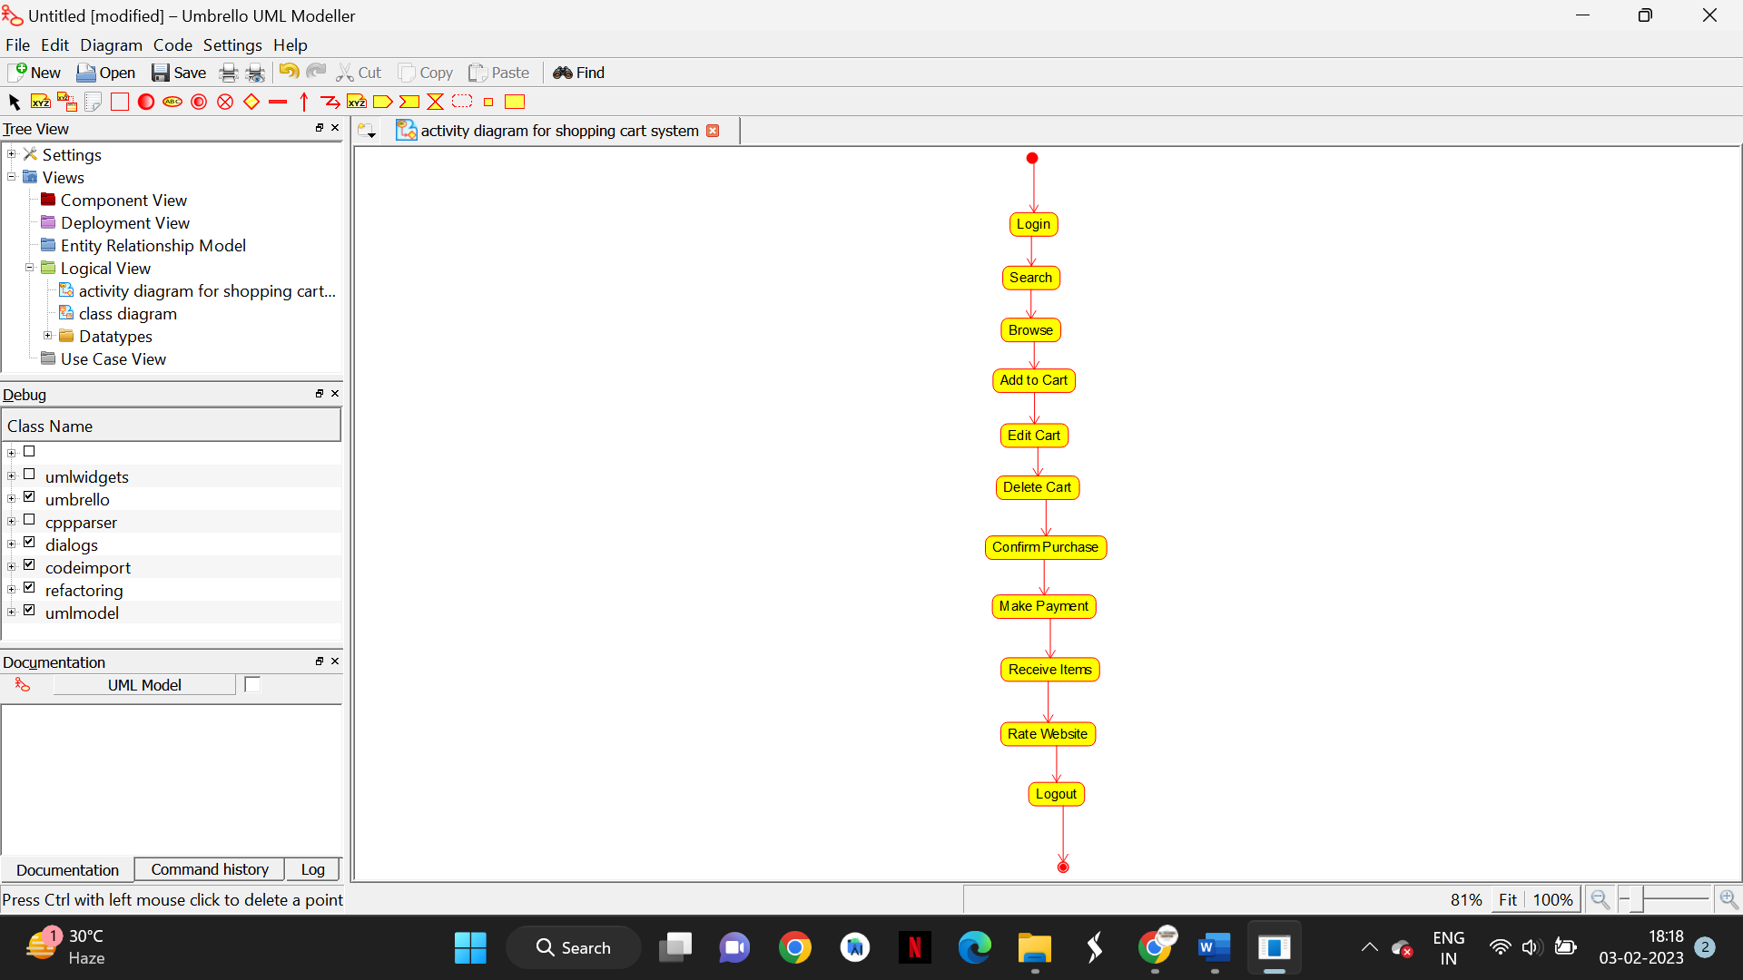

K.KARTHIK

192110178

**RESULT :**

Drawing a activity diagram for the Online Shopping cart System is completed successfully

**16)** Draw an Activity diagram for Online Railway Reservation System using CASE tools that the two actors would be a customer and a ticket counter having search train, check availability of train, if “yes” then go to booking of train if “no” Quit the system model. Print details like make payment, print ticket, cancel ticket, refund ticket feed details like name of the passenger, date and time of journey, amount of the journey

**AIM:**

To Draw a activity diagram for Online Railway reservation system Case tools

**SOFTWARE USED:**

Umbrello

**DIAGRAM:**

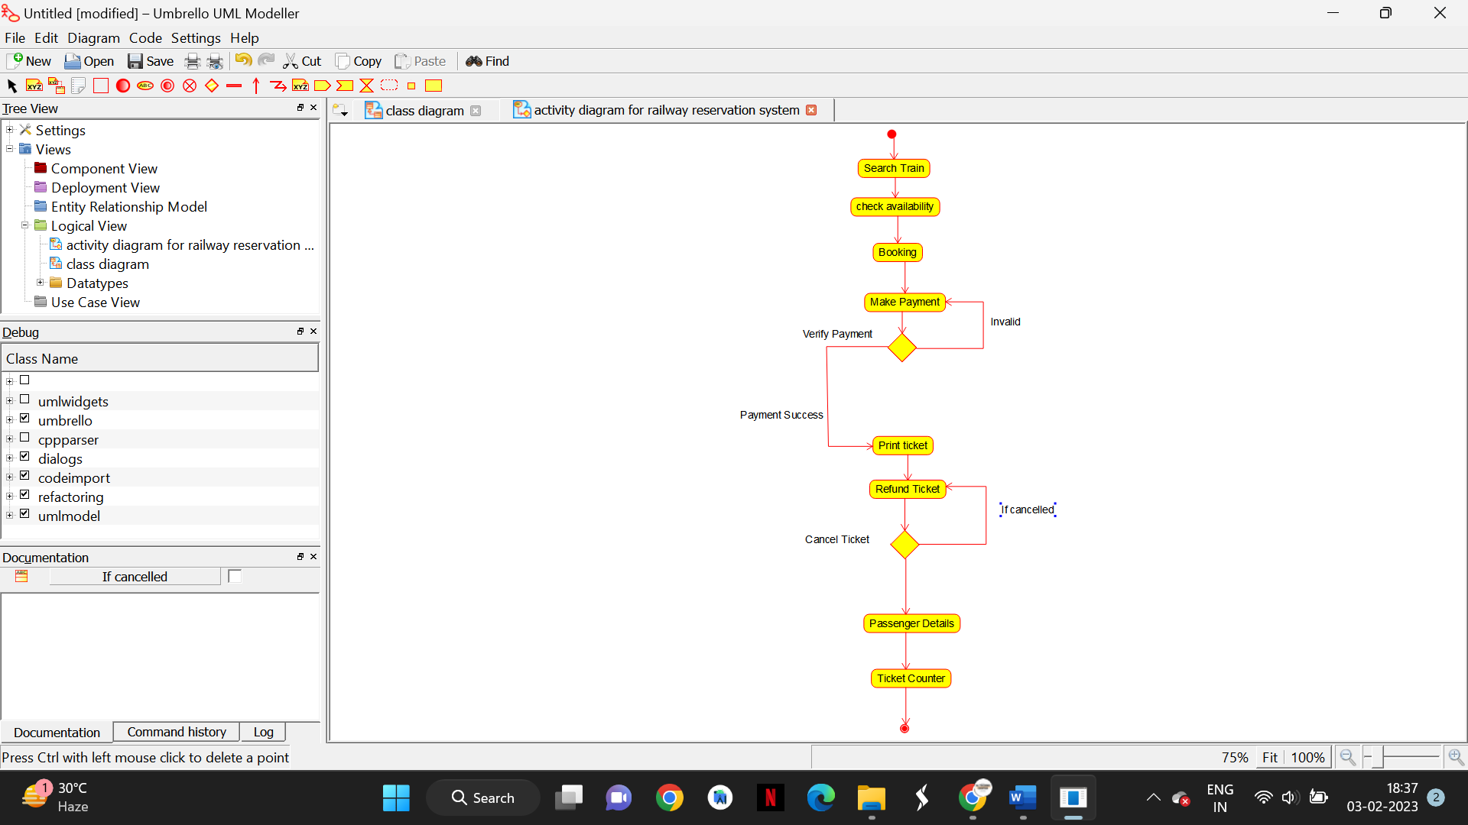

K.KARTHIK

192110178

**RESULT :**

Drawing a activity diagram for the Railway Reservation Online System is completed successfully

**17)** Draw an Activity diagram for Hospital Management System using CASE tools with Familiarizing activity Diagram Components, parts that are used to make the diagrams which determine the targeted users. Analyze the activities included plot of Hospital, Patient, Doctor, Receptionist the relationship . show how the user, the hospital staff, can interact with the system model.

**AIM:**

To Draw a activity diagram for Hospital Management system Case tools

**SOFTWARE USED:**

Umbrello

**DIAGRAM:** 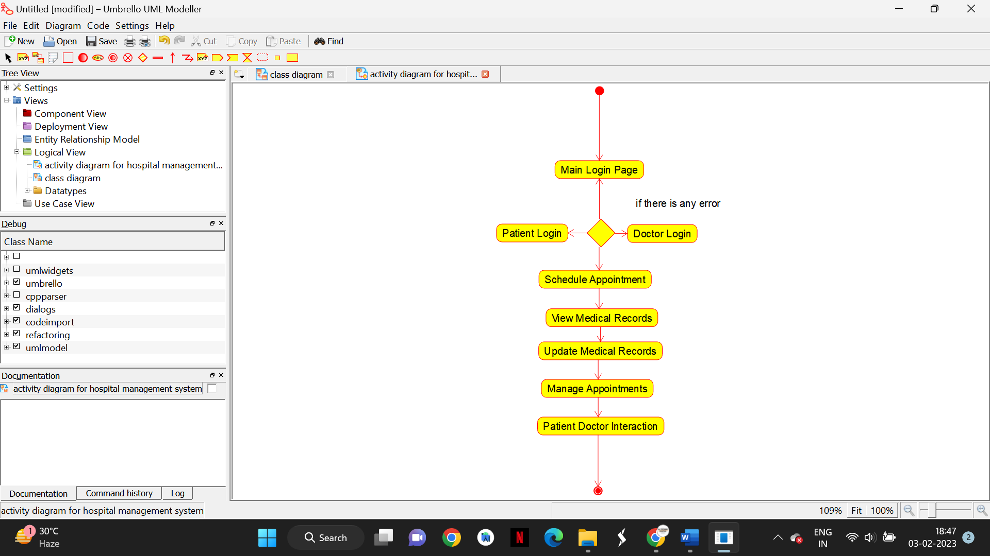

K.KARTHIK

192110178

**RESULT :**

Drawing a activity diagram for the hospital management System is completed successfully

**18)** Using Raptor- Draw the flowchart to check whether the given number is a palindrome or not. This scenario is a word, number, phrase, or other sequence of symbols that reads the same backwards as forwards. AdaptA method for this problem is to reverse digits of number, compare the reverse of number. If both are same, then return true, else false using Raptor tool.

**AIM:  
T**o Draw and validate flowchart to check the palindrome

**SOFTWARE USED:**

Raptor

**DIAGRAM**

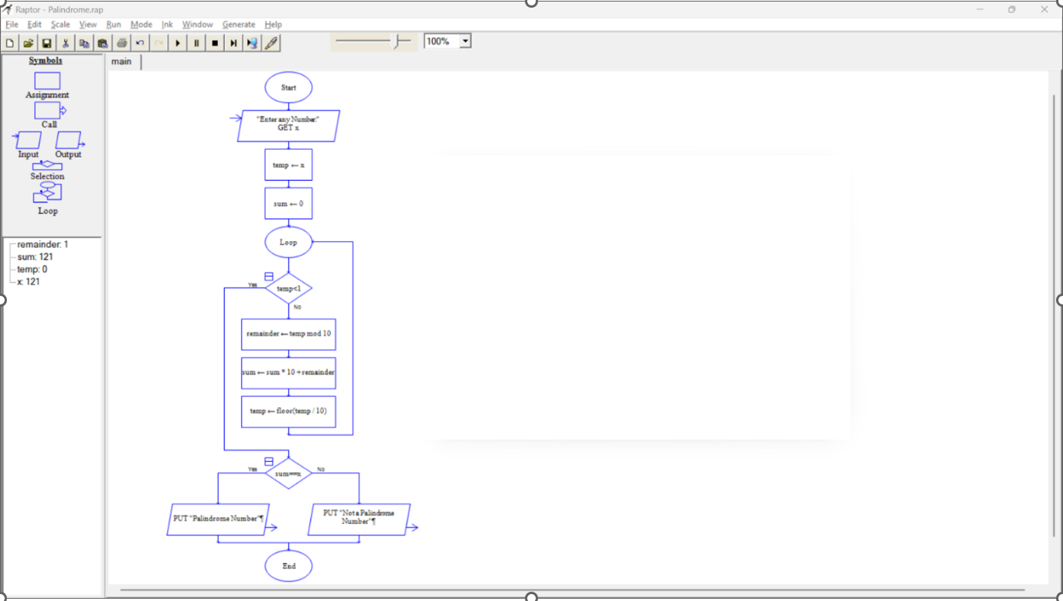

K.KARTHIK

192110178

**RESULT :**

Drawing and validating a flowchart to check palindrome is completed successfully

**19) Flow Chart to calculate fibonaaci series.**

**AIM:  
T**o Draw and validate flowchart to calculate Fibonacci series

**SOFTWARE USED:**

Raptor

**DIAGRAM**

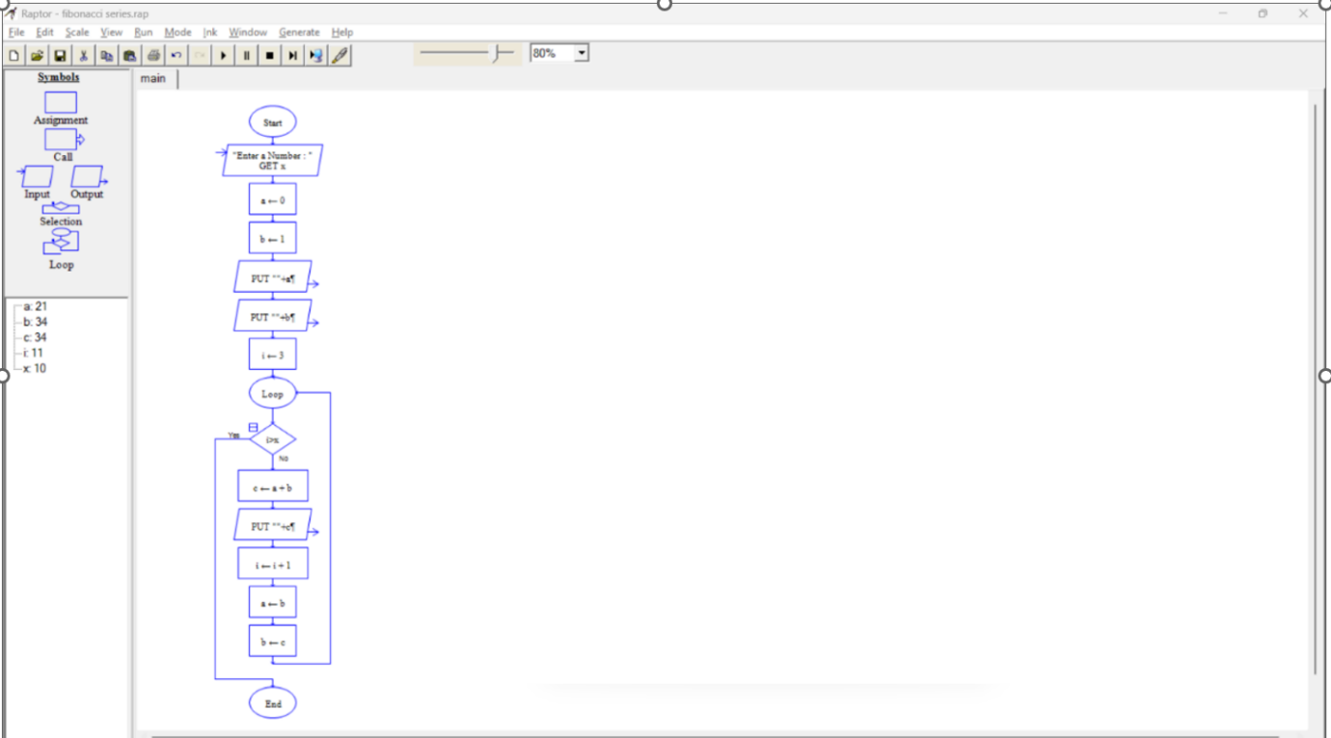

K.KARTHIK

192110178

**RESULT :**

Drawing and validating a flowchart to calculate the fibonaaci series is completed successfully

**20) Flow Chart to calculate cyclomatic complexity**

**AIM:  
T**o Draw and validate flowchart to calculate cyclomatic complexity

**SOFTWARE USED:**

Raptor

**DIAGRAM**

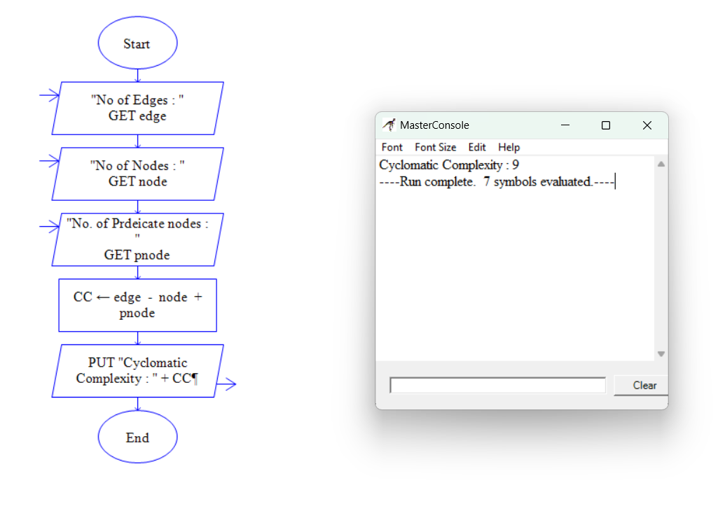

K.KARTHIK

192110178

**RESULT :**

Drawing and validating a flowchart to calculate the cyclomatic complexity is completed successfully

**21)** Using Raptor – Draw and validate a flowchart for a given string of lower case English alphabets. One can choose any two characters in the string and replace all the occurrences of the first character with the second character and replace all the occurrences of the second character with the first character. Using Raptor draw and validate the flowchart lexicographically smallest string that can be obtained by doing this operation at most once.

**AIM:  
T**o Draw and validate flowchart to lexicographically smallest string

**SOFTWARE USED:**

Raptor

**DIAGRAM:**



K.KARTHIK

192110178

**RESULT :**

Drawing and validating a flowchart to lexicographically smallest string

**22)** Draw a Use case diagram to model for a quiz system. A user can request a quiz for the system. The system picks a set of questions from its database, and composes them together to make a quiz. It rates the user’s answers and gives hints if the user requests it. In addition to users, we also have helpers who provide questions and hints. And also administrators who must certify questions to make sure they are not too trivial, and that they are correct

**AIM:**

To Draw a use case diagram for Quiz System using Case tools

**SOFTWARE USED:**

Umbrello

**DIAGRAM:**

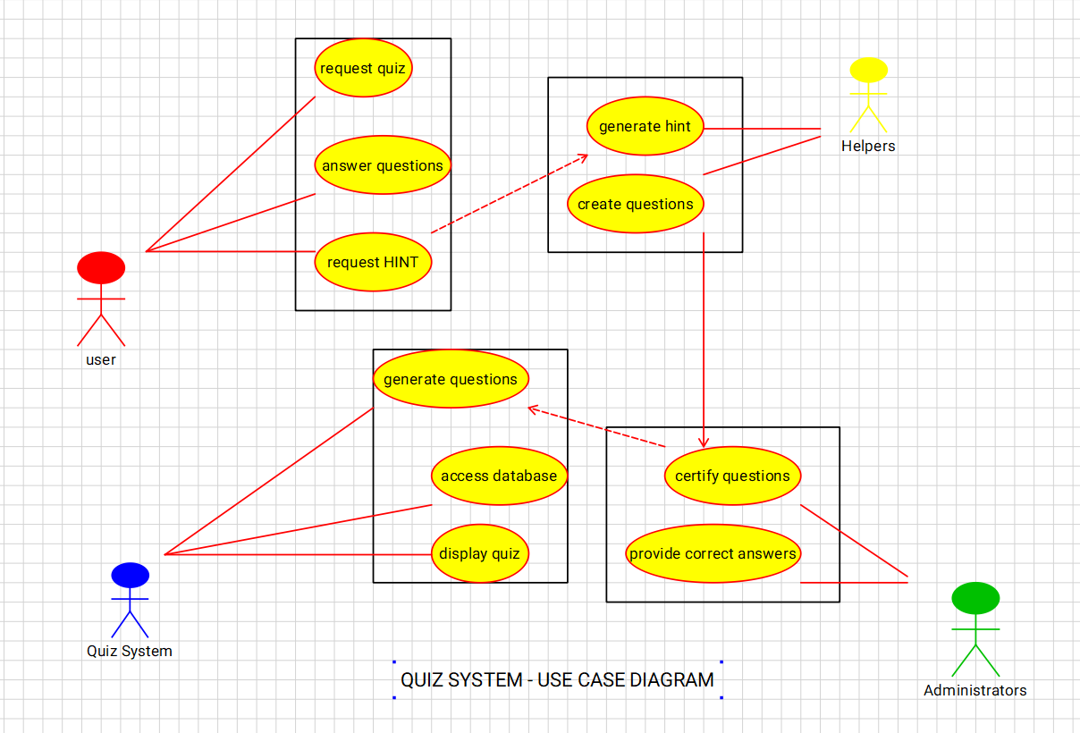

K.KARTHIK

192110178

**RESULT :**

Drawing a use case diagram for the Quiz System is completed successfully

**23)** Using Raptor- Draw and validate the flowchart to calculate Factorial of a number. Factorial of a positive integer (number) is the sum of multiplication of all the integers smaller than that positive integer. For example, factorial of 5 is 5 * 4 * 3 * 2 * 1 which equals 120.

**AIM:  
T**o Draw and validate flowchart to calculate factorial of a number

**SOFTWARE USED:**

Raptor

**DIAGRAM:**



K.KARTHIK

192110178

**RESULT :**

Drawing and validating a flowchart to calculate factorial of a number

**24)** Using Raptor – Draw and validate the flowchart to find odd series of the given number. The odd numbers are the numbers which are not divisible by 2. They are 1,3,5,7,9,11,13,15,17,19 etc..Using Raptor – Draw and validate the flowchart to find even series of the given number

**AIM:  
T**o Draw and validate flowchart to calculate odd series

**SOFTWARE USED:**

Raptor

**DIAGRAM:**



K.KARTHIK

192110178

**RESULT :**

Drawing and validating a flowchart to calculate odd series

**25)** Draw the flowchart that uses Raptor ,how to reverse a given String. If the string is "hello" then, the output should be "olleh". We can use this concept to check the palindrome. Because the palindrome string will have the same value even after we reverse it.

**AIM:  
T**o Draw and validate flowchart to reverse a string

**SOFTWARE USED:**

Raptor

**DIAGRAM:**



K.KARTHIK

192110178

**RESULT :**

Drawing and validating a flowchart to reverse a string

**26)** Draw the flowchart using Raptor,The formula of the sum of first n natural numbers is S=n(n+1)2S=n(n+1)2 . If the sum of first n natural number is 325 then find n.Using Raptor – Draw the flowchart to find largest of n numbers

**AIM:  
T**o Draw and validate flowchart to find sum of n natural numbers

**SOFTWARE USED:**

Raptor

**DIAGRAM:**



K.KARTHIK

192110178

**RESULT :**

Drawing and validating a flowchart to find sum of n natural numbers is completed successfully

**27)** Draw the flowchart using Raptor, Write a shell script to find the largest of n numbers in a range. Accept the size of a range (N) and accept each number in the range. Use an editor to write your script Change its permission to run as a script. Run your script with these sets of input below. The output should be preceded by the text "The largest number in this range is '' First range 5, the numbers are 4, 56, 78, 34, 123 Second range 6, the numbers are 99, 33, 1, 15, 25, 33 Find Cyclomatic Complexity for a graph having number of edges as 20, number of nodes as 15 and number of predicate nodes in the flow graph as 4

**AIM:  
T**o Draw and validate flowchart to find largest of n numbers in a range

**SOFTWARE USED:**

Raptor

**DIAGRAM:**



K.KARTHIK

192110178

**RESULT :**

Drawing and validating a flowchart to find largest of n numbers in a range is completed successfully

**28)** Using Raptor- Draw and validate the flowchart to calculate Fibonacci Series which plays a big part in Western harmony and musical scales. Here are the facts: An octave on the piano consists of 13 notes. Eight are white keys and five are black keys. A scale is composed of eight notes, of which the third and fifth notes create the foundation of a basic chord. In a scale, the dominant note is the fifth note, which is also the eighth note of all 13 notes that make up the octave. Eight divided by 13 equals 0.61538 the approximate Golden Ratio. Using Raptor, draw and validate the flowchart.

**AIM:  
T**o Draw and validate flowchart to calculate Fibonacci series

**SOFTWARE USED:**

Raptor

**DIAGRAM:**



K.KARTHIK

192110178

**RESULT :**

Drawing and validating a flowchart to find calculate Fibonacci series completed successfully

**29)** E-wallet is an online prepaid account where one can stock money, to be used when required. As it is a pre-loaded facility, consumers can buy a range of products from airline tickets to grocery without swiping a debit or credit card. You are required to design a similar EWallet Management System (EMS) using Use case diagram

**AIM:**

To Draw a use case diagram for E-wallet system using Case tools

**SOFTWARE USED:**

Umbrello

**DIAGRAM:**

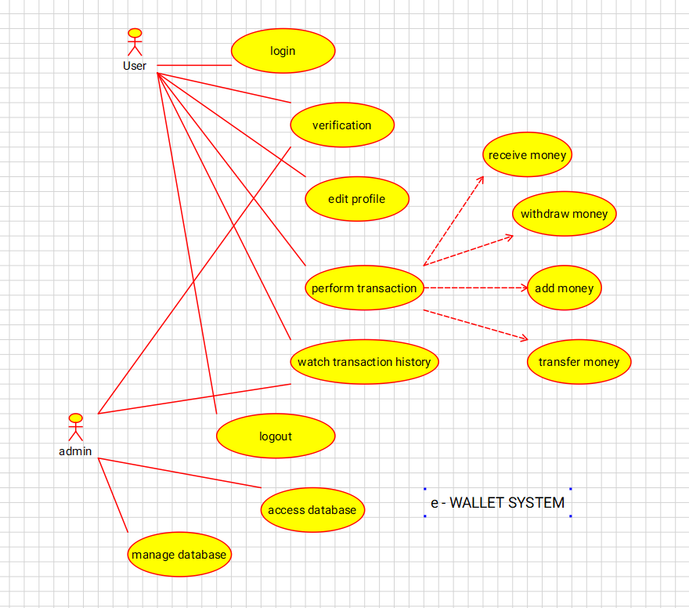

K.KARTHIK

192110178

**RESULT :**

Drawing a use case diagram for the E-wallet system is completed successfully

**30)** A college has more than thousand security persons, who are instructed to give duties at different places within the campus. Additionally, they also maintain a routine, which contains all information, such as Date, Duty Start Time, Duty End Time, and Place. Most importantly, all the places are covered by at least one security person. If a security person takes leave, manual entry is done against that person. Finally, at the end of a month, the security persons get paid for their duties, while considering the number of leaves as well. You can see that the manual calculation/operation is a heavy task for the security manager. Therefore, the objective is to build an Online security management system using class diagram through which entire security system within the campus can be controlled in an efficient manner

**AIM:**

To Draw a class diagram for College Security System using Case tools

**SOFTWARE USED:**

Umbrello

**DIAGRAM:**

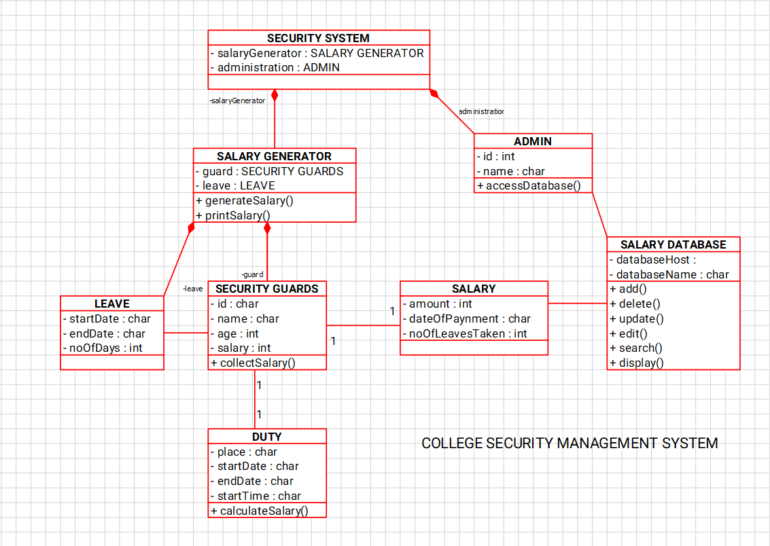

K.KARTHIK

192110178

**RESULT :**

Drawing a class diagram for the college security system is completed successfully

**31)** The Internet has led to discussion of e-democracy and online voting. Many people think that the internet could replace representative democracy, enabling everyone to vote on everything and anything by online voting .Online voting could reduce cost and make voting more convenient. This type of voting can be done for e-democracy, or it may be used for finalizing a solution, if many alternatives are present. Online voting make’s use of authentication, hence it needs security, and the system must be able to address obtaining, marking, delivering and counting ballots via computer. Advantage of online voting is it could increase voter turnout because of convenience, and it helps to reduce fraud voting.

**AIM:**

To Draw a activity diagram for e-democracy System using Case tools

**SOFTWARE USED:**

Umbrello

**DIAGRAM:**

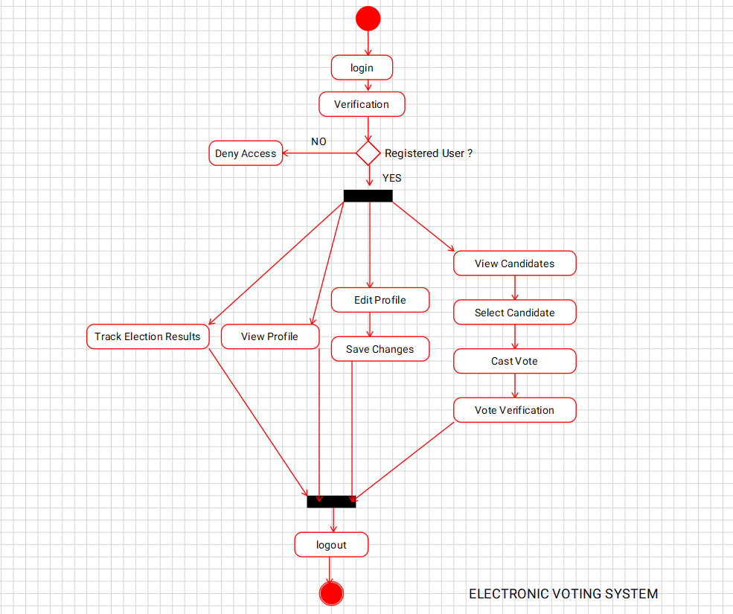

K.KARTHIK

192110178

**RESULT :**

Drawing a activity diagram for the e-democracy system is completed successfully

**32)** Construct a flowchart using raptor and Check whether a string is palindrome or not a palindrome is a word, number, phrase, or other sequence of symbols that reads the same backwards as forwards, such as the words madam or race car

**AIM:  
T**o Draw and validate flowchart to check palindrome

**SOFTWARE USED:**

Raptor

**DIAGRAM:**



K.KARTHIK

192110178

**RESULT :**

Drawing a flowchart to check the palindrome number

**33)** The string is a sequence of characters placed in double quotes (” “). Performing different operations on string data is called String Handling. Strings are immutable. Whenever a change to a String is made, an entirely new String is created. If we want to store a group of characters we can use a char array. String Provides various methods to perform different operations on strings Using Raptor draw a flowchart to display the total number of characters in the string and return it.

**AIM:  
T**o Draw and validate flowchart to display total number of characters

**SOFTWARE USED:**

Raptor

**DIAGRAM:**



K.KARTHIK

192110178

**RESULT :**

Drawing a flowchart to display total number of characters is completed successfully

**34)** Take for example the RSA encryption system: All arithmetic is done modulo n, with n=pq and p, q large primes. Decryption in this system relies on computing Euler's phi function, φ(n), which is hard to compute (hence the system is hard to break) **unless** you know the prime factorization of n (which is also hard to compute unless you know it upfront). Hence you need a method to generate primes (the Miller-Rabin primality checking algorithm is usually used here) and then you construct n by multiplying the primes you have found. Using Raptor, draw the flowchart to find whether p and q are prime or not.

**AIM:  
T**o Draw and validate flowchart to display the number is prime or not for example RSA encryption system

**SOFTWARE USED:**

Raptor

**DIAGRAM:**



K.KARTHIK

192110178

**RESULT :**

Drawing a flowchart to display the number is prime or not is completed successfully

**35)** Make a class diagram to model for a quiz system. A user can request a quiz for the system. The system picks a set of questions from its database, and composes them together to make a quiz. It rates the user’s answers and gives hints if the user requests it. In addition to users, we also have helpers who provide questions and hints. And also administrators who must certify questions to make sure they are not too trivial, and that they are correct.

**AIM:**

To Draw a class diagram for quiz system using Case tools

**SOFTWARE USED:**

Umbrello

**DIAGRAM:**

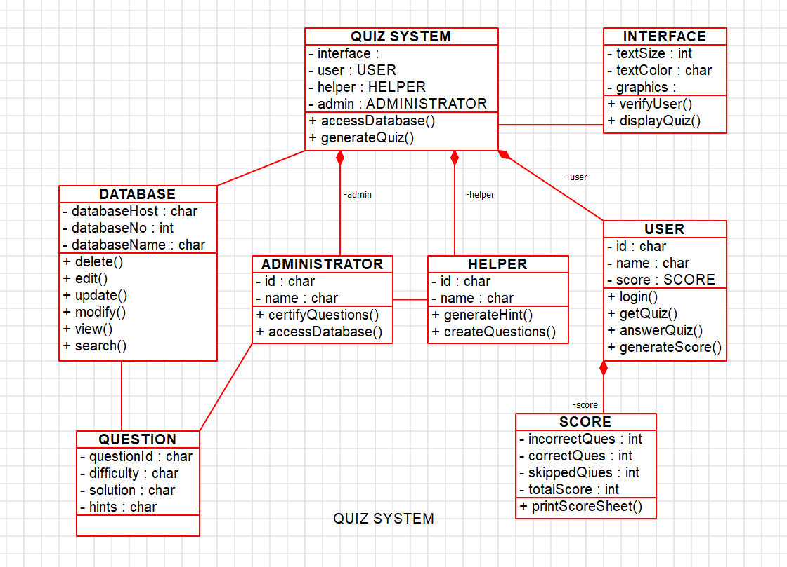

K.KARTHIK

192110178

**RESULT :**

Drawing a class diagram for quiz system is completed successfully

**36)** Draw a Class diagram for a Restaurant Systems. The activities of the Restaurant system are listed below. Receive the Customer food orders, Produce the customer ordered foods, Serve the customer with their ordered foods, Collect payment from Customers, Store customer payment details, Order Raw Materials for food products, Pay for Raw Materials and Pay for Labour.

**AIM:**

To Draw a class diagram for restaurant system using Case tools

**SOFTWARE USED:**

Umbrello

**DIAGRAM:**

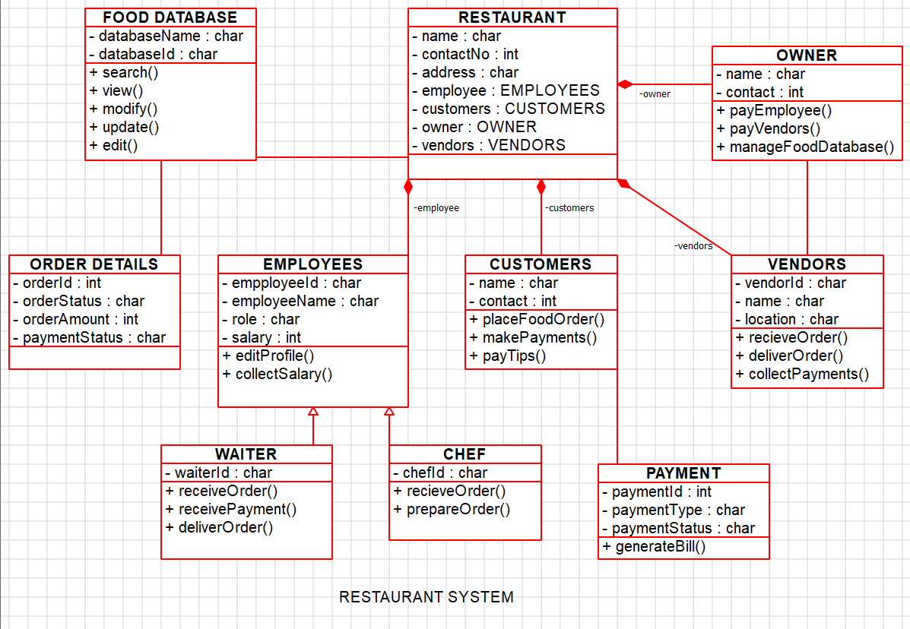

K.KARTHIK

192110178

**RESULT :**

Drawing a class diagram for restaurant system is completed successfully

**37)** Draw a USE-CASE diagram for an ATM System using CASE tool. The banking system allows a customer to access the financial transactions by ATM System, it has a step by step process describing the work of this process and elaborate what work can be done by customer, banking system, administrator and technicians with the ATM system.

**AIM:**

To Draw a use case diagram for ATM system using Case tools

**SOFTWARE USED:**

Umbrello

**DIAGRAM:**

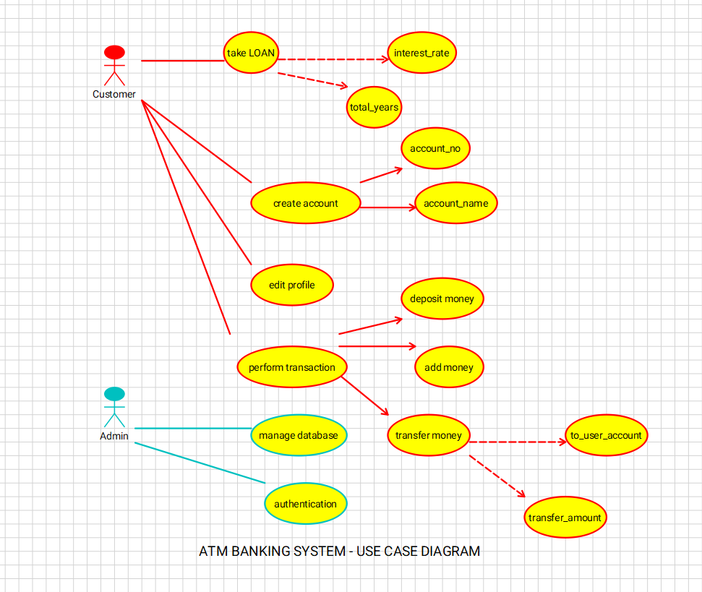

K.KARTHIK

192110178

**RESULT :**

Drawing a use case diagram for ATM system is completed successfully

**38)** Draw a USE-CASE diagram for Online Airline Management System which is a dedicated and highly configurable system for all airlines, which can be easily accessed by all users. It helps the users to book flights without visiting offline booking counters. This system can be accessible by any user from any location at any time. In such a system, a passenger should be able to view the availability of flights’ details, as per their requirement. They can book the flights online and can also cancel the reservation. The administrator manages the passenger booking system and updates the reservation status using CASE tools

**AIM:**

To Draw a use case diagram for Online Airline Management system using Case tools

**SOFTWARE USED:**

Umbrello

**DIAGRAM:**

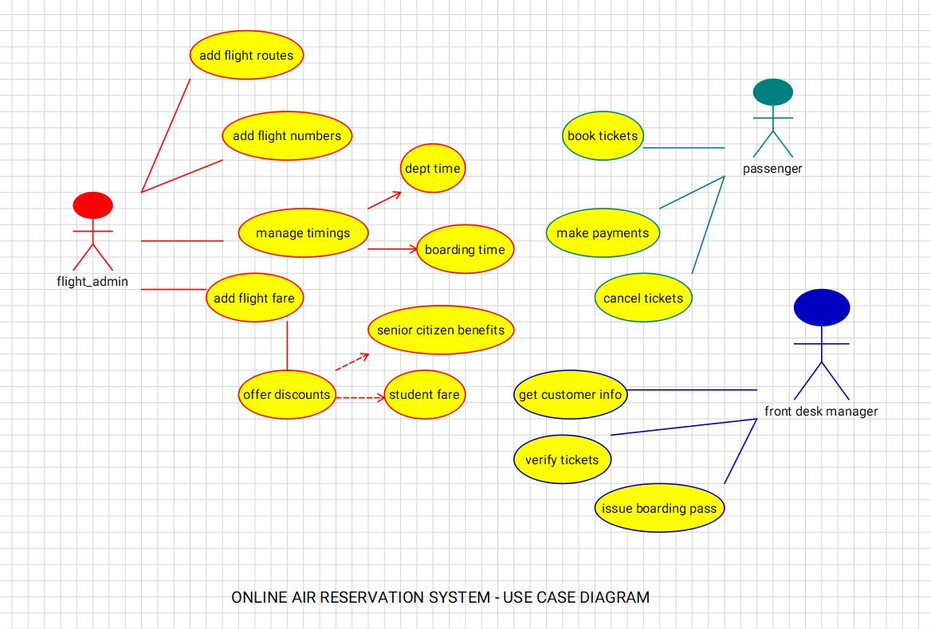

K.KARTHIK

192110178

**RESULT :**

Drawing a use case diagram for online airline management system is completed successfully

**39)** Draw a Activity diagram for Online Voting System for a software platform that allows groups to securely conduct votes and elections using CASE tools. The voters should be able to register via some proper authority. Construct a system in which the voters should see the list of candidates present in his constituency. A voter should be able to cast his vote to a candidate and that voter should cast only 1 vote at a timeDraw an Activity diagram for Library Management System using CASE tools.

**AIM:**

To Draw activity diagram for Online Voting system using Case tools

**SOFTWARE USED:**

Umbrello

**DIAGRAM:**

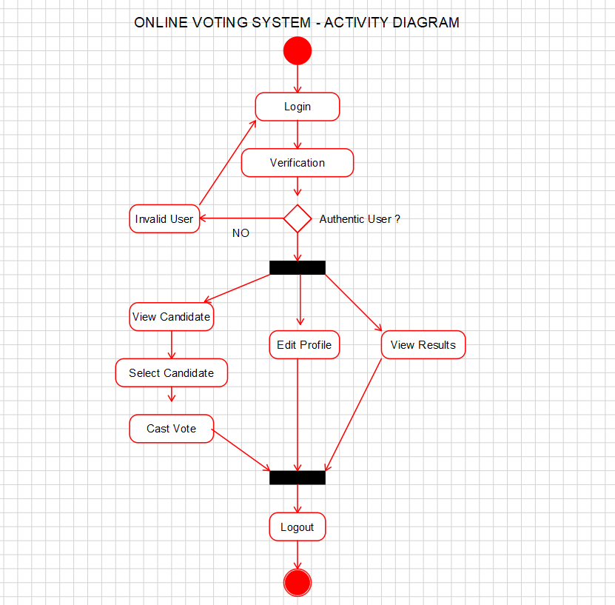

K.KARTHIK

192110178

**RESULT :**

Drawing a use case diagram for online airline management system is completed successfully

**40)** Draw a Activity diagram for Library Management System using CASE tools constructing User who registers himself as a new user initially who is regarded as staff or student. After getting the library card, a new book is requested by the user. After, requesting, the desired book issue the book to the user. Renew the book if the user needs the book again. Add the agent as Librarian and the user in the activity diagram

**AIM:**

To Draw activity diagram for Library Manage system using Case tools

**SOFTWARE USED:**

Umbrello

**DIAGRAM:**

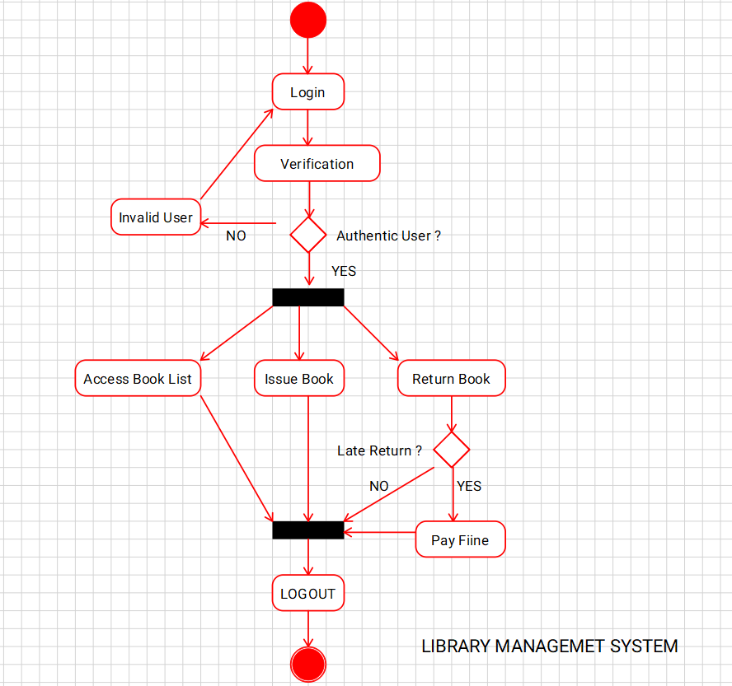

K.KARTHIK

192110178

**RESULT :**

Drawing a use case diagram for library management system is completed successfully